Week 12

Question 1:
A binary number is a combination of 1s and 0s. Its n^{th} least significant digit is the n^{th} digit starting from the right starting with 1. Given a decimal number, convert it to binary and determine the value of the the 4th least significant digit.
Input Format:
Input from stdin will be processed as follows and passed to the function. The only line contains an integer, number.
Sample Input 1:
32
Sample Output 1:
0
Program:
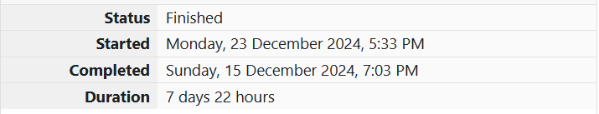
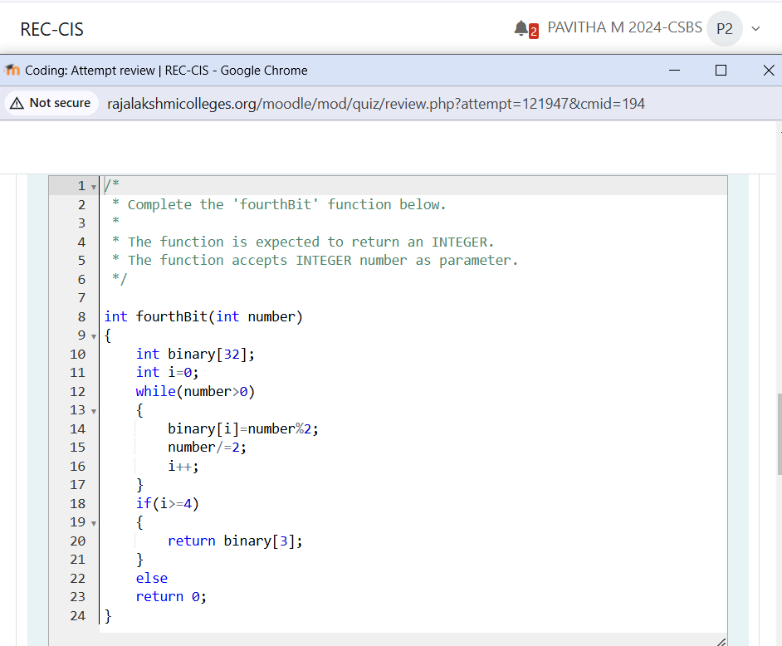
Output:
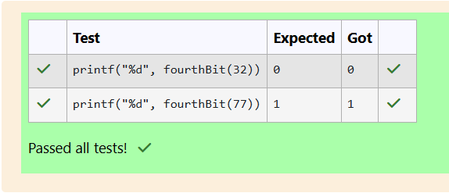

Question 2:
Determine the factors of a number (i.e., all positive integer values that evenly divide into a number) and then return the p^{th} element of the list, sorted ascending. If there is no p^{th} element, return 0.
Input Format:
Input from stdin will be processed as follows and passed to the function. The first line contains an integer n, the number to factor. The second line contains an integer p, the 1-based index of the factor to return.
Sample Input 1:
10
5
Sample Output 1:
0
Program:
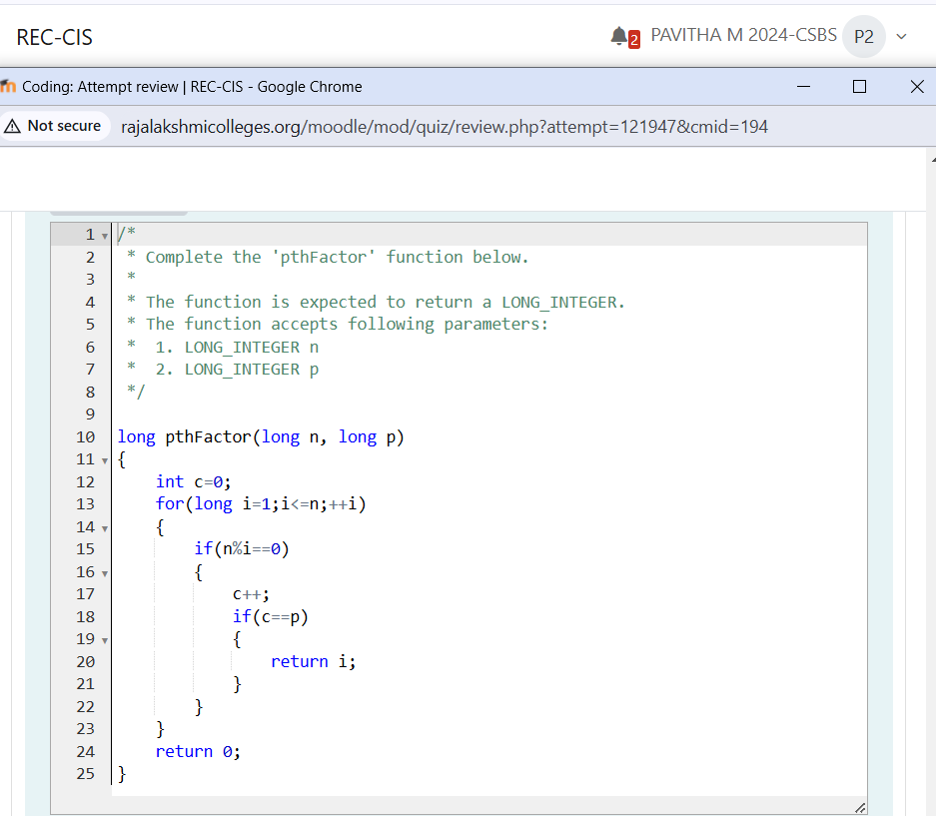

Output:

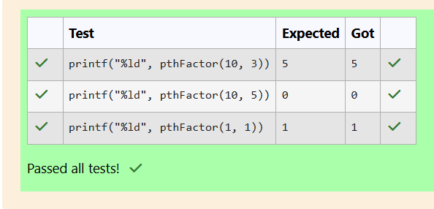

Question 3:
You are a bank account hacker. Initially you have 1 rupee in your account, and you want exactly N rupees in your account. You wrote two hacks, first hack can multiply the amount of money you own by 10, while the second can multiply it by 20. These hacks can be used any number of time. Can you achieve the desired amount N using these hacks.
Input Format:
The test case contains a single integer N.
Output Format:
For each test case, print a single line containing the string "1" if you can make exactly N rupees or "0" otherwise.
Sample Input 1:
2
Sample Output 1:
0
Program:
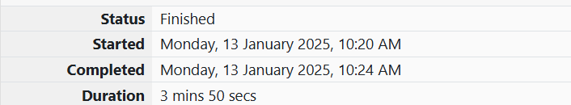
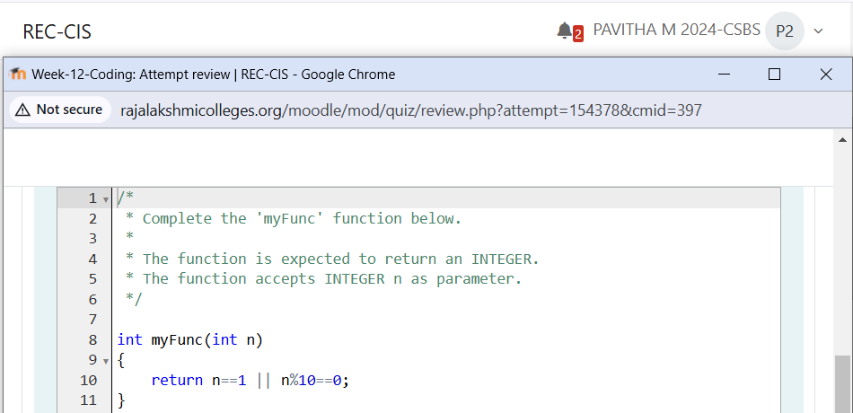
Output:
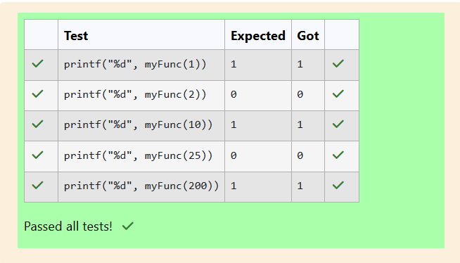

Question 4:
Find the number of ways that a given integer, X, can be expressed as the sum of the N^{th} powers of unique, natural numbers. For example, if X = 13 and N = 2, we have to find all combinations of unique squares adding up to 13. The only solution is 2² + 3².
Input Format:
The first line contains an integer X.
The second line contains an integer N.
Output Format:
Output a single integer, the number of possible combinations calculated.
Sample Input 1:
10
2
Sample Output 1:
1
Program:

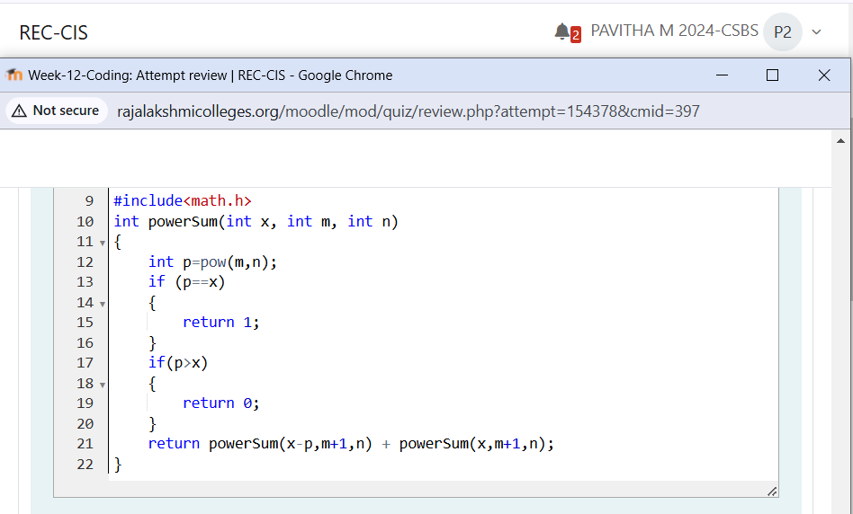

Output:
